Please return this document to Jennifer Reed, Jennifer.reed@semanticbits.com, or Paul Baumgartner, Paul.baumgartner@semanticbits.com

Enter the tester information in the first table. Capture the version number needs in each of the individual tests since we may be releasing periodic updates.

Tester Information

Name | Robin Heinze
Test date | 8/28/08
Computer OS | Windows Vista
Computer browser version | Firefox v 3.0.1 (Mozilla/5.0 (Windows; U; Windows NT 6.0; en-US; rv:1.9.0.1) Gecko/2008070208 Firefox/3.0.1)
Program
Program Version | caAERS v 1.3.1
Program URL | Hosted demo, https://sbdev1000.semanticbits.com:18031/caaers/public/login  or a properly installed local version of 1.3

The first test I tried using Firefox and got the following errors and therefore did not proceed with the test with this browser:

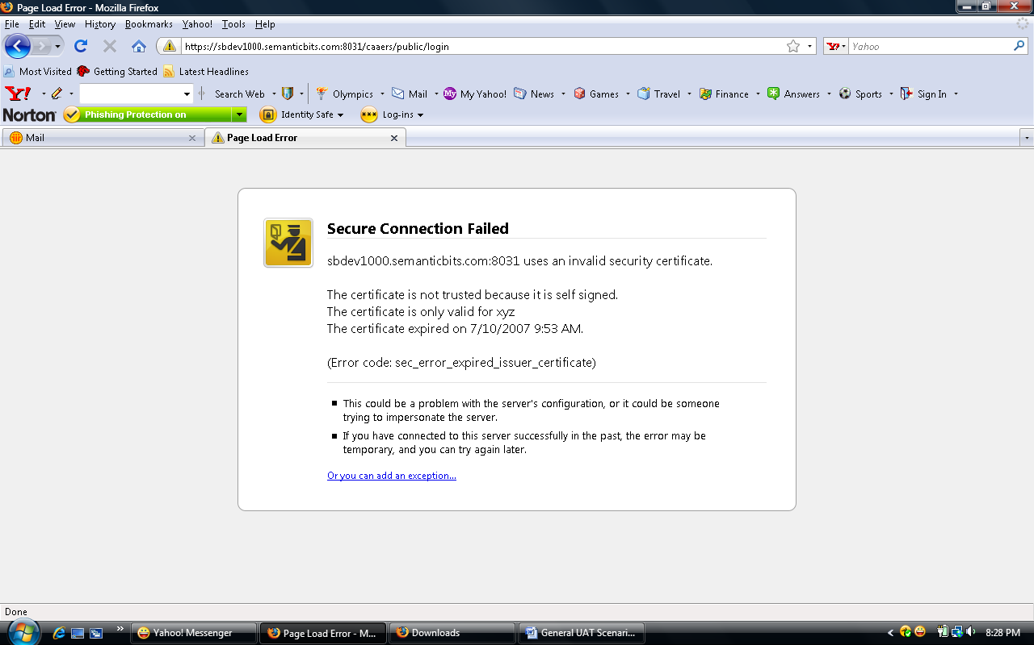

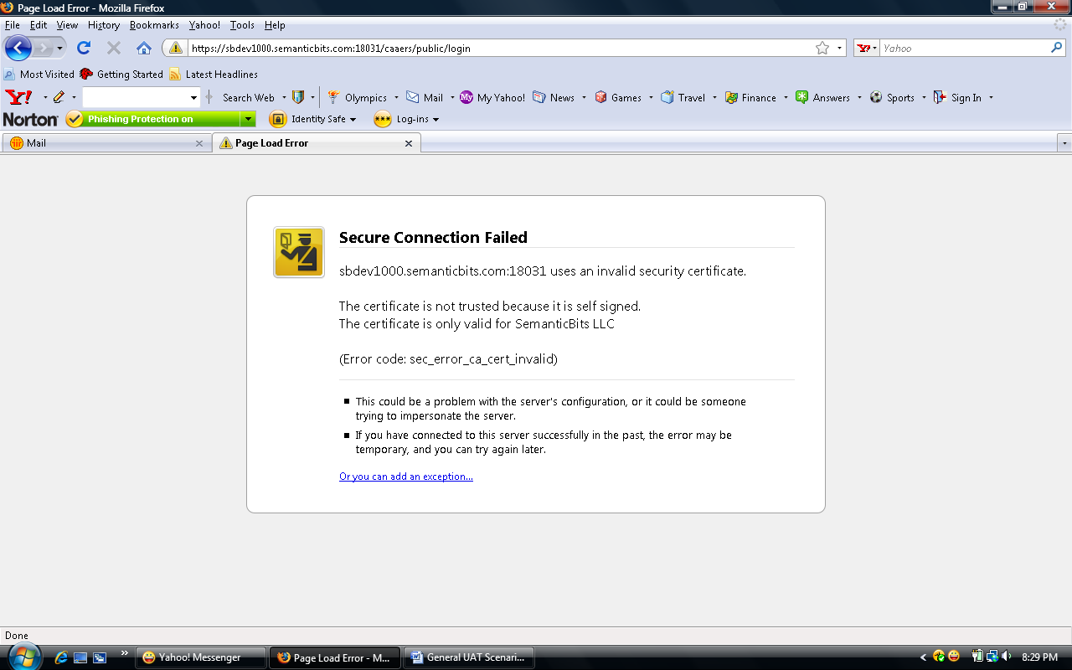

Name | Robin Heinze
Test date | 8/28/08 and 9/4/08
Computer OS | Windows Vista
Computer browser version | Ie 7.0
Program
Program Version | caAERS v 1.3.1
Program URL | Hosted demo, https://sbdev1000.semanticbits.com:18031/caaers/public/login  or a properly installed local version of 1.3

Study Module

User Story | - add reporting period types  - add solicited AEs to a study
Scenario Description | Open an existing study in caAERS. Add a reporting period type for the study. Add one or more solicited AEs that you want to collect data on.
caAERS Version | (v1.3, v1.3.1, v 1.3.2, etc)
Behaved as expected? | Yes
General Comments (what you liked, what you didn’t like) | It was a little slow
Specific Issues (bugs)
Issues to raise (improvements)

User Story | - delete reporting period type  - delete solicited AEs
Scenario Description | Open a study that is already in caAERS. Remove the Post-treatment reporting period. The investigator is done collecting information on a certain AE, so delete it.
caAERS Version | (v1.3, v1.3.1, v 1.3.2, etc)
Behaved as expected? | yes
General Comments (what you liked, what you didn’t like) | Maybe have a warning when deleting a solicited AE like you have for deleting the period type.
Specific Issues (bugs)
Issues to raise (improvements)

User Story | add MedDRA version for "other"
Scenario Description | Open an existing study in caAERS. Verify the Disease terminology vocabulary and add the MedDRA version to use when you choose "Other - specify" as the AE term.
caAERS Version | (v1.3, v1.3.1, v 1.3.2, etc)
Behaved as expected? | maybe
General Comments (what you liked, what you didn’t like) | I wasn’t sure at first what you meant by “disease terminology vocabulary.” And there was only one MedDRA version to choose from.
Specific Issues (bugs)
Issues to raise (improvements) | On the disease tab, when you clear the disease category, it should also clear the subcategories and diseases.

User Story | Create instructions to be displayed when capturing Baseline AEs
Scenario Description | Open an existing study in caAERS. Add instructions to be displayed on the AE collection screen when you collect Baseline AEs.
caAERS Version | (v1.3, v1.3.1, v 1.3.2, etc)
Behaved as expected? | Yes, with issues
General Comments (what you liked, what you didn’t like)
Specific Issues (bugs) | Instructions added, but didn’t show up when I tried to enter report for patient jane doe on 30601.
Issues to raise (improvements)

User Story | Add solicited AE to list - reporting period already created for a patient
Scenario Description | - Create a Treatment reporting period for a patient & add an AE.  - Close the patient and open the study  - Add one or more solicited AEs for the Treatment reporting period  - Save the study and open the patient study combination again  - Open the treatment reporting period again. Do the newly added solicited AEs appear?  - Create a new Treatment reporting period. Do the newly added solicited AEs appear?
caAERS Version | (v1.3, v1.3.1, v 1.3.2, etc)
Behaved as expected? | no
General Comments (what you liked, what you didn’t like)
Specific Issues (bugs) | Couldn’t do step 2- see screen shots below. Without step 2, couldn’t continue
Issues to raise (improvements)

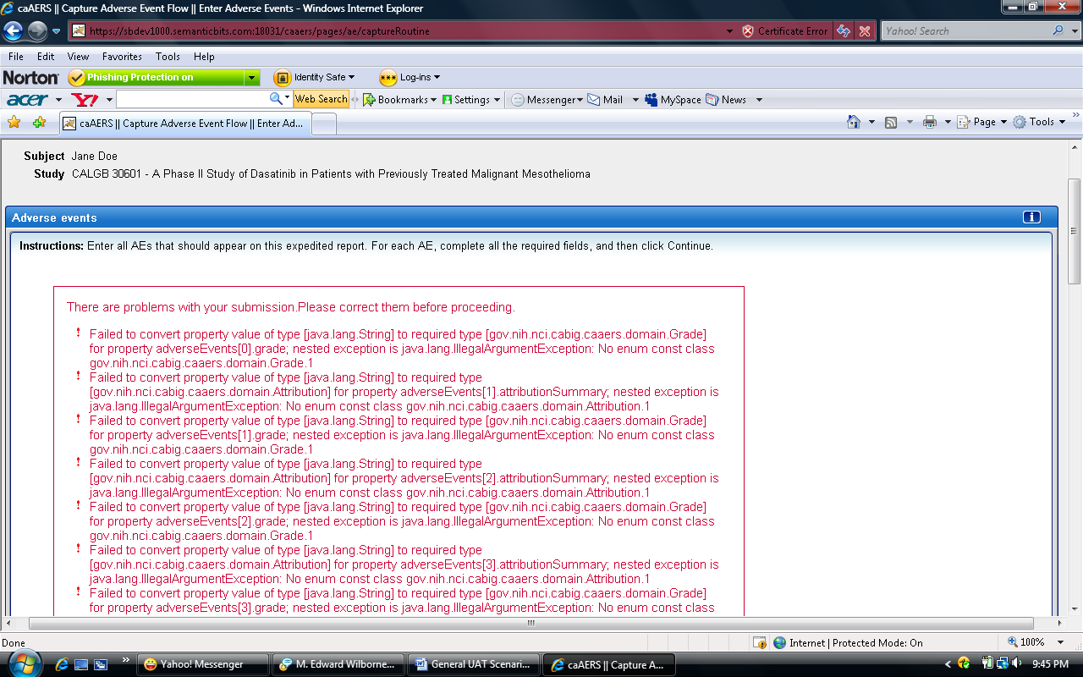

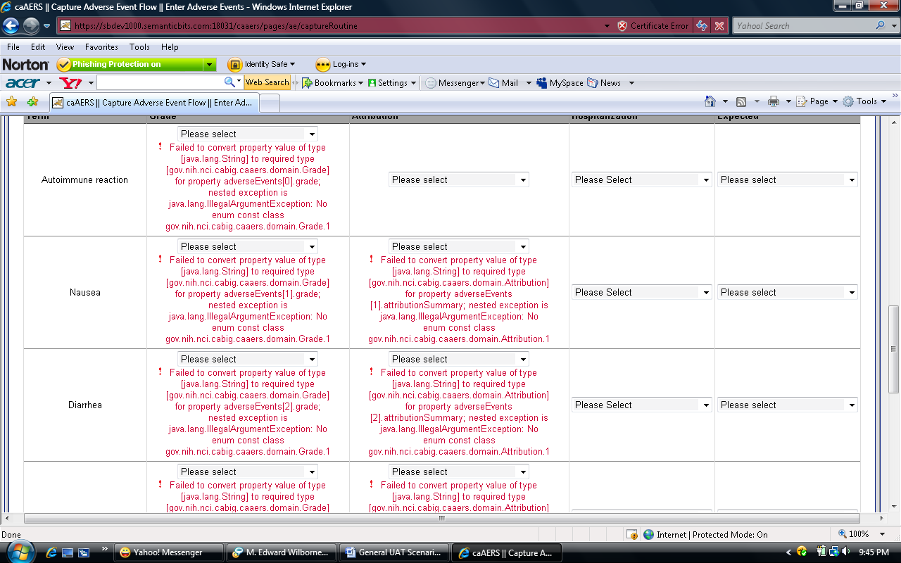

User Story | Delete a reporting period type - reporting period type used
Scenario Description | - Create a Treatment reporting period for a patient & add an AE.  - Close the patient and open the study  - Delete the Treatment reporting period type  - Save the study and open the patient study combination again  - Open the treatment reporting period again. What does it show for the reporting period type?
caAERS Version | (v1.3, v1.3.1, v 1.3.2, etc)
Behaved as expected? | No, see previous user story.
General Comments (what you liked, what you didn’t like)
Specific Issues (bugs)
Issues to raise (improvements)

User Story | Create a study manually
Scenario Description | Add a new study to caAERS  - does it require all the expected fields?  - does it require fields that it shouldn't?
caAERS Version | (v1.3, v1.3.1, v 1.3.2, etc)
Behaved as expected? | No, see specific issues.
General Comments (what you liked, what you didn’t like)
Specific Issues (bugs) | I entered CTC as the terminology, but got the error message that it was missing (see below). Also, the CTC version and other MedDRA version, if required should have the red star.  I purposely left a few required fields blank to check the error messages. The first time I clicked continue, it caught only those errors. When I corrected the blank fields and hit continue, I got the error messages below about the terminology. It would be better to have all errors appear at once.  When I first clicked “add study agent”, the boxes to enter information did not appear in the right place (see second screen shot below).
Issues to raise (improvements) | If you choose CTC as terminology, you should be required to specify the version.  The little “x’s” to delete (a treatment assignment for example) are too small and not intuitive. A delete button would be better.  Under reporting period types, the option to delete the baseline report was not available and should be as not all studies require a baseline report.

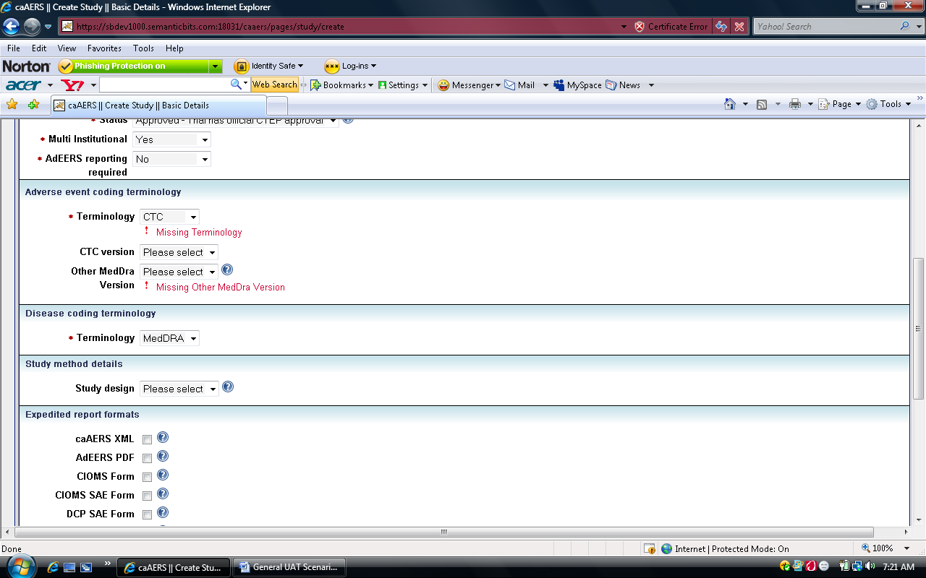

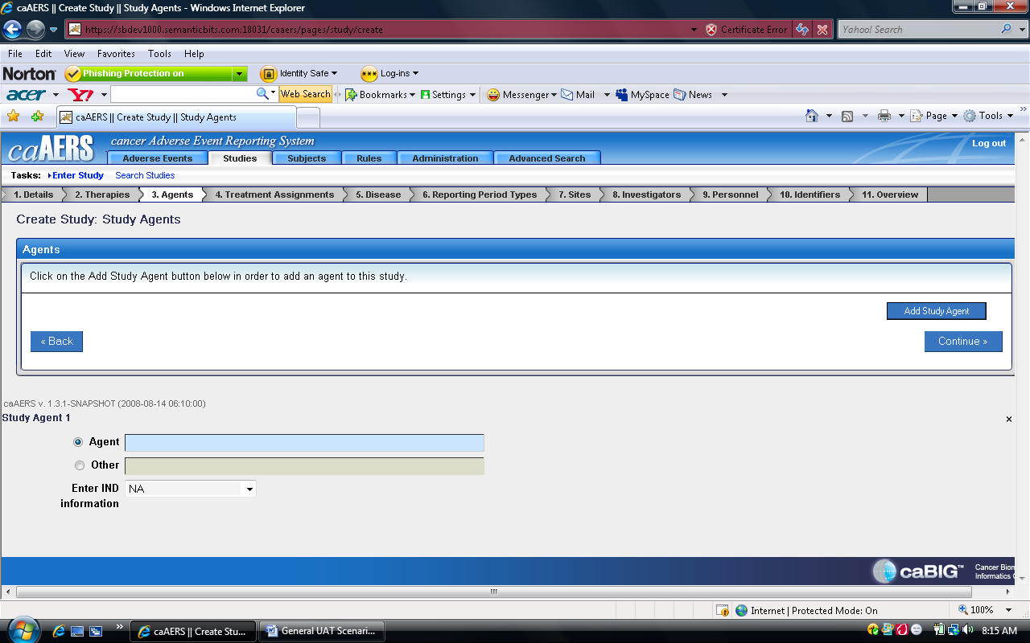

AE Module

User Story | Create a reporting period
Scenario Description | Open a patient/study combination and add a reporting period where you can collect AEs.
caAERS Version | (v1.3, v1.3.1, v 1.3.2, etc)
Behaved as expected? | yes
General Comments (what you liked, what you didn’t like)
Specific Issues (bugs)
Issues to raise (improvements)

User Story | Modify a reporting period - change the type
Scenario Description | Open a patient/study combination to which you've already added a reporting period. Change the reporting period type and save.
caAERS Version | (v1.3, v1.3.1, v 1.3.2, etc)
Behaved as expected? | yes
General Comments (what you liked, what you didn’t like) | I didn’t like that the only option beside Reporting period AEs is “create” which is confusing if you want to edit an existing reporting period.
Specific Issues (bugs)
Issues to raise (improvements) | Either have separate buttons for creating a new reporting period and editing an existing one, or change the link to read “Edit or Create.”

User Story | Modify a reporting period - change the dates
Scenario Description | Open a patient/study combination to which you've already added a reporting period. Change the date and save.
caAERS Version | (v1.3, v1.3.1, v 1.3.2, etc)
Behaved as expected? | yes
General Comments (what you liked, what you didn’t like)
Specific Issues (bugs)
Issues to raise (improvements)

User Story | Document Baseline AEs
Scenario Description | Open a patient/study combination and add Baseline AEs for the patient. Baseline AEs are AEs that are captured at the time of registration and are thus not reported on.
caAERS Version | (v1.3, v1.3.1, v 1.3.2, etc)
Behaved as expected? | no
General Comments (what you liked, what you didn’t like)
Specific Issues (bugs) | See screen shot- I got this when I tried to save and continue.
Issues to raise (improvements)

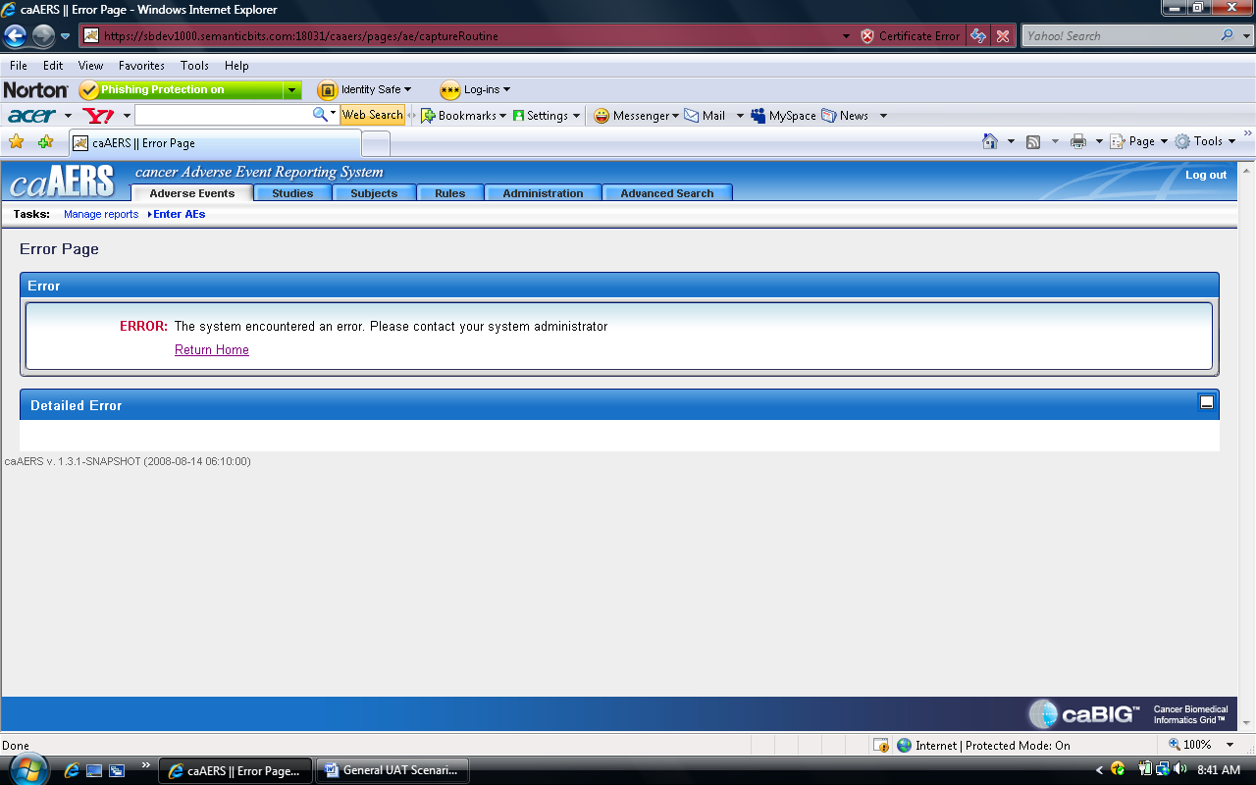

User Story | Document treatment AEs
Scenario Description | Open a patient/study combination and add Treatment AEs for the patient.
caAERS Version | (v1.3, v1.3.1, v 1.3.2, etc)
Behaved as expected? | No- see previous shots for user story “Add solicited AE to list - reporting period already created for a patient.”
General Comments (what you liked, what you didn’t like)
Specific Issues (bugs)
Issues to raise (improvements)

User Story | Save incomplete AE data for a reporting period
Scenario Description | - Open a patient/study combination and add multiple Treatment AEs for the patient.  - Leave the Grade blank and click Save.  - Exit, then bring the same patient/study combination & treatment reporting period. Was the AE info saved?  - Click Save & Continue without making changes. Does it behave as expected?
caAERS Version | (v1.3, v1.3.1, v 1.3.2, etc)
Behaved as expected? | yes
General Comments (what you liked, what you didn’t like)
Specific Issues (bugs)
Issues to raise (improvements)

User Story | Select a different report than suggested
Scenario Description | Open a patient/study combination and add multiple Treatment AEs for the patient.
caAERS Version | (v1.3, v1.3.1, v 1.3.2, etc)
Behaved as expected? | No- see previous shots for user story “Add solicited AE to list - reporting period already created for a patient.”
General Comments (what you liked, what you didn’t like)
Specific Issues (bugs)
Issues to raise (improvements)

User Story | Add additional AEs to a reporting period
Scenario Description | - Go to Manage Reports for a patient/study combination  - Select a reporting period  - Enter Additional AEs  - Modify existing AEs  - Click Save & Continue
caAERS Version | (v1.3, v1.3.1, v 1.3.2, etc)
Behaved as expected? | No see previous shot for user story “Document Baseline AEs.”
General Comments (what you liked, what you didn’t like)
Specific Issues (bugs)
Issues to raise (improvements)

User Story | Complete an expedited report
Scenario Description | - Go to Manage Reports for a patient/study combination  - select an expedited report  - complete the expedited report
caAERS Version | (v1.3, v1.3.1, v 1.3.2, etc)
Behaved as expected? | no
General Comments (what you liked, what you didn’t like)
Specific Issues (bugs) | Could not generate an expedited report (see screen shot below) because the rows were blank.
Issues to raise (improvements)

